President's Report for the 2023 Calendar Year
It was a busy year for Millmerran Arts Council with six exhibitions, three Arts Council presented productions, two workshops, and involvement in another four community events.
​
As they say, many hands make light work, and that was certainly the case this year for our passionate committee members, whom through eight general meetings, organised a vast program of arts activity for the Millmerran community.

Speaking of many hands, and in this case many hats too, Lyndelle Pfeffer has contributed to a multitude of community groups and events in the district and like them all, we were sad to see her depart the Arts Council committee following her recent relocation. Lyndelle has been part of the Arts Council for many years and in various roles, including Vice President and Exhibitions Officer. We are most grateful for her vast contributions.
​
Our other many hands making up the committee for 2023 were Raelene Antonio, Leanne Brittan, Nell Macqueen (Interim Exhibitions Officer from Oct), Sheryle Rogers (Treasurer and Interim Officer Secretary), Margaret Stevens, and Pat Taylor (Vice President).
We welcomed new local, Natasha Lim into our committee meetings from earlier this year when she commenced organising the Music for All Program over the weekend of 5 August featuring Celtic music workshops and a bush dance. This event was well organised considering the very short timeframes she had to work with. A very welcome addition to our committee meetings and the community.

Like all volunteer groups, we would love to welcome new or renewing members into our committee to be involved in the organisation of 3-4 community initiatives annually as well as the set up of bi-monthly exhibitions at the Millmerran Library. Our mission is simple! To grow Millmerran’s participation in arts and cultural experiences and creative endeavours, as well as deliver opportunities for artists to connect with our community. Just look at the sorts of things we did this year….

Following our last AGM, we proposed several events for school aged students via meetings with Lawson Short at St Joseph’s and Pearta Nolan and Kate Barton at Millmerran State School (MSS). Both meetings were incredibly productive and led to growth in school student participation in Arts Council events in 2023 as outlined further below.

In March, the Arts Council set up a stand at the Millmerran Show with committee members making themselves available to share information about what the Arts Council does and taking membership applications.

Across the year, our Library exhibitions were launched every two months and featured an array of local artists across various mediums, including; Tim Ballinger (photography), Sophie Twidale (acrylic painting), Lexi Antonio and students (mixed media artworks), in June/July for NAIDOC Barbara Walker (weaving), Howard Flynn (woodwork), Darcie Harris (illustrations I wish I was a Farmer), Millmerran State School (Yr. 9 & 10 Visual Arts elective student works).

To coincide with her library exhibition for NAIDOC, proud Wiradjuri woman from Wagga Wagga NSW (living in Pittsworth), Barbara Walker, conducted weaving workshops in an Arts Council collaboration with Millmerran Community Support Service and Millmerran Library. The result was offering free workshops for children (value $40 per child) during the mid-year school holidays and for adults (value $80 per adult) in June. In the end, we had 25 participants with a whole bunch of beautiful woven creations and a new skill they can build upon or share with others.

On Saturday 6 May, we once again showed our support to Yallambee Auxiliary at its annual Mother’s Day Market, with a stall of local artist works available for sale. It was wonderful to showcase and sell items in support of local artists, Geoff Bolton, Christine Turner, Chris Moreno, Lexi Antonio, Raelene Antonio, and Debra O’Halloran. Millmerran Arts Council also supported the live music program for the day with Cathy Drummond and Wylahra Jam Band taking to the stage and entertaining the crowds. Raffle proceeds for the Tim Ballinger gifted framed photograph were also donated to the Yallambee Auxiliary.

On Tuesday 16 May, the Arts Council set up a paper-craft mouse-making workstation at Millmerran’s Under 8’s Day. This was an interactive preview to our later presentation of Twinkle and the Moon, based on a book featuring the character, Twinkle, the mouse.

The Arts Council’s presentation of The Wind in the Willows by Queensland’s RAVA Productions, brought local school students by the busload to fill the Millmerran Cultural Centre on Friday 16 June. 280 students from MSS and St Joseph’s attended in addition to a small group of MSS senior drama elective students who participated in a tailored drama workshop after the performance.
​
The aforementioned Twinkle the mouse came to life in a wonderfully engaging performance of Twinkle and the Moon on Friday 25 August at the MSS Hall. Millmerran Arts Council has been working with Red Chair for a few years to present this page-to-stage performance by author, actor, and singer Nadia Sunde. Designed to encourage a love of reading and confidence in imaginative play, this was a magical event for around sixty local Kindy, Prep and Year 1 students in attendance.

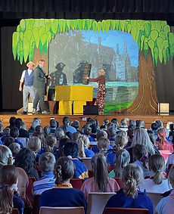

The Wind in The Willows

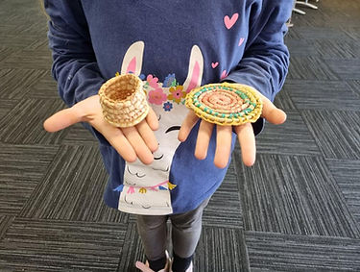

Children’s Basket Weaving Workshop

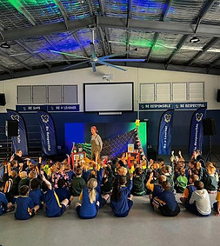

Twinkle and the Moon

On 18 October, the Arts Council proudly supported MSS to present Didjeribone to 233 students. Queensland based international performer Adrian Fabila Tjupurrula AKA Tjupurru, is a descendant of the Djabera Djabera Tribe of the Western Australia Kimberleys. Tjupurru played the didjeribone, an Australian Made and designed instrument fusing the elements of the didgeridoo and trombone. Tjupurru shared his inspiring personal journey, the history of his culture and the expressions of Aboriginal art and music, enriching a deeper understanding of Indigenous culture.

The busy year concluded with a visit by members of the Queensland Symphony Orchestra as part of its Connect initiative. A dedicated Quintet and Orchestra staff worked with school students of Millmerran and Pittsworth, including Millmerran State School Concert Band and Black Inc Pittsworth Community Band, to deliver an incredibly inspiring performance event on 8 November at the Millmerran Cultural Centre. This truly was a highlight for the Millmerran cultural calendar in 2023 and whilst not an Arts Council initiative, is worthy of a mention given the Orchestra’s cultural significance and the huge contribution by the Doug Hall Foundation to make this happen in Millmerran.

Many of our Arts Council initiatives would not occur without the generous support of the Doug Hall Foundation throughout the year to supplement our Membership funds. This year we would also like to acknowledge the support from Captains Mountain Wind Farm, Millmerran Commerce and Progress Association, Millmerran Community Support Service, Millmerran Library, Christine Turner, and Tim Ballinger. You have all truly made Millmerran Arts Council initiatives possible and helped us in some way to grow Millmerran’s participation in arts and cultural experiences and creative endeavours in 2023.
​
Angela Perrin, President, Millmerran Arts Council

